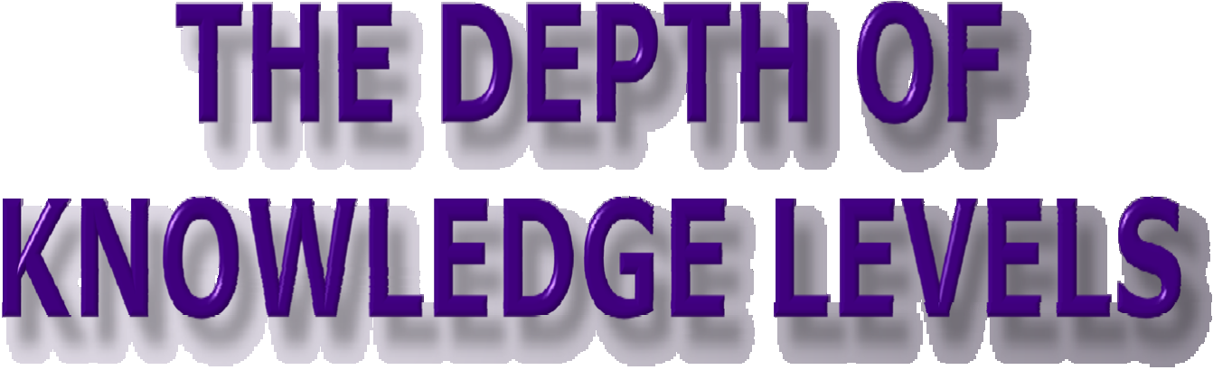

Key Points

The Depth of Knowledge measures the degree to which the knowledge elicited from students on the assessment is as complex as what students are expected to know and do as stated in the standards.

Teachers can no longer rely on “tell-me-what-I-told-you” assessments; new assessments must be created requiring students to demonstrate and apply what they have learned.

Instruction, assignments, and classroom assessment must incorporate the same expectations. DOK levels for a targeted objective must mirror the DOK level for the assessment.

Teachers need to examine if their required student work and activities are keeping students engaged in activity or engaged in learning. Not all activities help students learn.

What is Depth of Knowledge (DOK) Model?

Adapted from the model used by Norman Webb, University of Wisconsin, to align standards with assessments
Focuses on content standard in order to successfully complete an assessment item/task

Descriptive, not a taxonomy
Not the same as ability levels (A1, A2, A3) and DOK
is more consistent

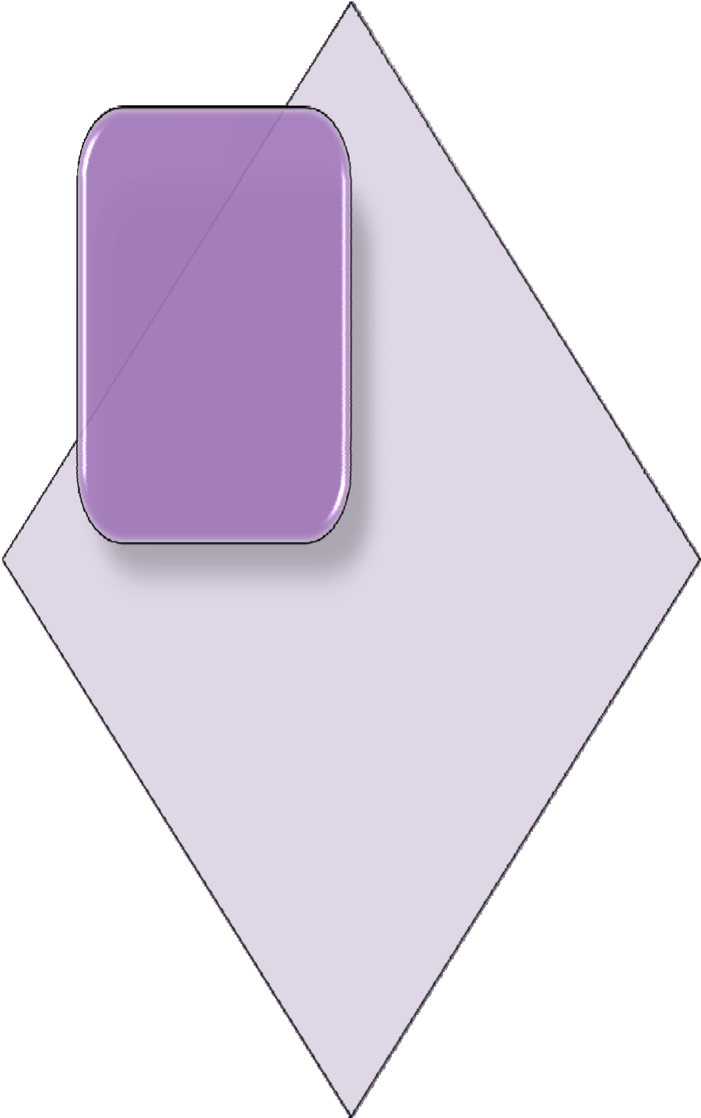

Why Depth of Knowledge?

No Child Left Behind (NCLB) requires assessments to “measure the depth and breadth of the state academic content standards for a given grade level”

(U.S. Department of Education, 2003, p. 12)

Why Depth of Knowledge?

Mechanism to ensure that the intent of the standard and the level of student demonstration required by that standard matches the assessment items
(required under NCLB)

DOK is a tool to ensure that teachers are teaching to a level that will promote student achievement

DOK
Levels
- Depth of Knowledge levels:

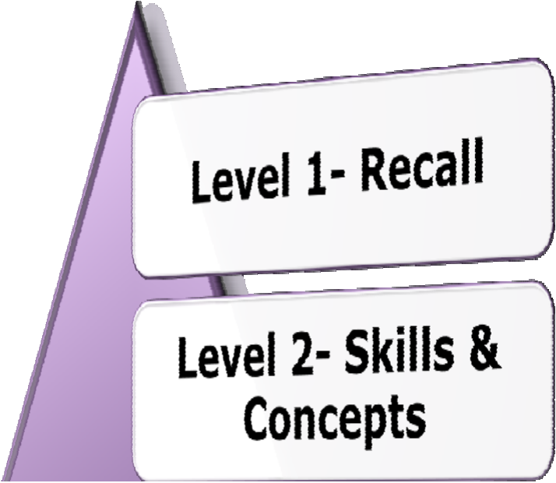

DOK Level 1:
Recall and Reproduction

Basic recall of concepts, definitions, facts, and processes

Answering a Level 1 item can involve following a simple, well-known procedure or formula

Simple skills and abilities or recall characterize DOK 1

Locate or recall facts found in text

Apply a well-known formula

Use a dictionary to find the meaning of words

Represent math relationships in words, pictures, or symbols

Perform a simple science process or a set of procedures

DOK Level 2:
Basic Application of Skills & Concepts

DOK 2 includes the engagement of some mental processing beyond recalling or reproducing a response.

Items require students to make some decisions as to how to approach the question or problem.

These actions imply more than one mental or cognitive process/step.

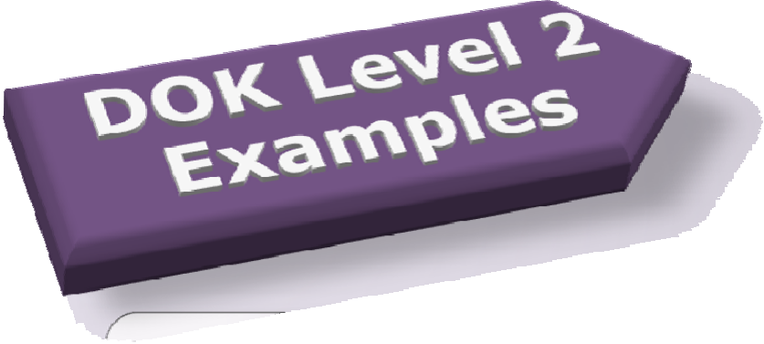

Identify and summarize the major events, problem, solution, conflicts in literary text

Explain the cause-effect of historical events

Predict a logical outcome based on information in a reading selection

Retrieve information from a table, graph, or figure and use it to solve a problem requiring multiple steps.

Level 3:
Strategic Thinking

DOK 3 requires deep understanding as exhibited through planning, using evidence, and more demanding cognitive reasoning.

The cognitive demands at Level 3 are complex and abstract.

An assessment item that has more than one possible answer and requires students to justify the response they give would most likely be a Level 3.

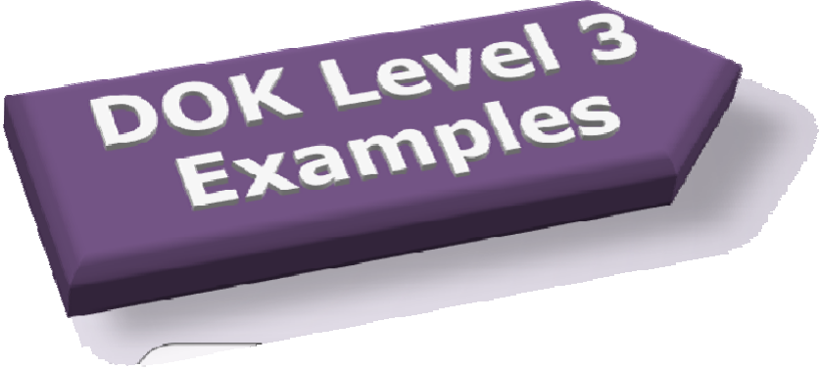

Compare consumer actions and analyze how these actions impact the environment

Analyze or evaluate the effectiveness of literary elements (e.g. characterization, setting, point of view, conflict and resolution, plot structures)

Solve a multiple-step problem and provide support with a mathematical explanation that justifies the answer

Develop a scientific model for a complex idea

Justify a response when more than one answer is possible

Propose and evaluate solutions for an economic problem

Level 4:
Extended Thinking

DOK 4 requires high cognitive demand and is very complex.

An investigation or application that requires time to research, think or process multiple conditions of the problem.

Students are expected to make non-routine manipulations or connections across disciplines/content areas/multiple sources.

Due to the complexity of cognitive demand, DOK 4 requires an extended period of time.

There will be DOK level 4 questions on the PARCC assessment.

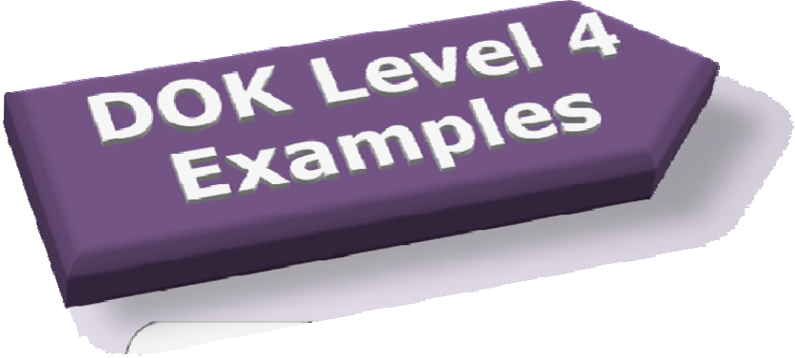

Gather, analyze, organize, and synthesize information from multiple sources to draft a reasoned report

Analyze and explain multiple perspectives or issues within or across time periods, events, or cultures

Specify a problem, identify solution paths, solve the problem, and report the results

Write and produce an original play

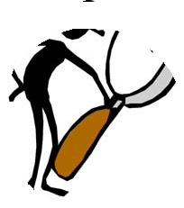
However, extended time alone is not the distinguishing factor of a Level 4.

Task | Thinking
Collecting data samples over several months | Recall
Organizing the data in a chart | Skills/ concepts
Using this chart to make and justify predictions | Strategic Thinking
Developing a generalized model from this data and applying it to a new situation | Extending Thinking

Is DOK different from Bloom’s Taxonomy?
.

The Depth of Knowledge is NOT determined by the verb, but the context in which the verb is used and the depth of thinking required.

DOK 3- Describe a model that you might use to represent the relationships that exist within the rock cycle. (Requires deep understanding of rock cycle and a determination of how best to represent it)

DOK 2- Describe the difference between metamorphic and igneous rocks. (Requires cognitive processing to determine the differences in the two rock types)

DOK 1- Describe three characteristics of metamorphic rocks. (Simple recall)

Same verb—used at all three DOK levels

DL on DOK Levels

DOK levels can be cumulative
An item/standard written to DOK 3 often contains DOK 1 and DOK 2 level demands
Not all standards can be assessed at a level 3 or 4.
DOK 1 + DOK 1 DOK 2

To Summarize…

Depth of Knowledge (DOK) is a scale of cognitive demand.

DOK requires looking at the assessment item/standard in order to determine the level. DOK is about the item/standard-not the students’ ability.

The context of the assessment item/standard must be considered to determine the DOK- not just a look at what verb was chosen.

